Lambda & API Gateway-Assignment

AWS Lambda is a serverless compute service that lets you run code without provisioning or managing servers.

In simple terms
You just write your code, upload it to Lambda, and AWS runs it for you whenever it’s needed.

Key concepts of AWS Lambda

1. Serverless
- No EC2 instances to manage
- No OS patching or capacity planning
- AWS handles scaling, availability, and maintenance

2. Event-driven
Lambda functions run only when triggered by an event, such as:
- File upload to S3
- API request via API Gateway
- Database change in DynamoDB
- Message from SNS / SQS
- Scheduled job (CloudWatch/EventBridge)

3. Pay per use
- You pay only for execution time
- No cost when the function is idle

How AWS Lambda works (basic flow)
- An event occurs (e.g., file uploaded to S3)
- The event triggers the Lambda function
- Lambda executes your code
- Output is sent to logs, another service, or a response

Supported languages
- Python
- Node.js (JavaScript)
- Java
- C#
- Go
- Ruby

Common real-world example
S3 → Lambda → SNS
- A file is uploaded to an S3 bucket
- Lambda processes the file
- Lambda sends a notification using SNS
(You’ve already been working on similar AWS workflows 👍)

Advantages
✔ Automatic scaling
✔ High availability
✔ No server management
✔ Cost-effective for short tasks

Limitations
⚠ Execution time limit (up to 15 minutes)
⚠ Not suitable for long-running processes
⚠ Cold start latency (minor delay sometimes)

When to use Lambda
- Automating AWS tasks
- Backend for APIs
- Data processing
- File/image processing
- Scheduled jobs (cron)

Task Title
S3 Event-Based Email Notification Using AWS Lambda and SNS

Objective
To automatically send an email notification whenever an object is uploaded to an Amazon S3 bucket by triggering an AWS Lambda function and publishing a message to an Amazon SNS topic.

Architecture Overview
Amazon S3 → AWS Lambda → Amazon SNS → Email

Prerequisites
- AWS Account
- IAM role with permissions for:
  - AWS Lambda
  - Amazon S3
  - Amazon SNS
  - CloudWatch Logs
- Verified email address for SNS subscription

Create AWS Lambda Function
- Service: AWS Lambda
- Function name: s3-event-notification
- Runtime: Python 3.14
- Architecture: x86_64
- Execution role: Default Lambda role with CloudWatch access

Lambda Code (basic example):
- Logs the S3 event
- Returns a success response
- Used later as a trigger target for S3 events
✅ Lambda function created and tested successfully.

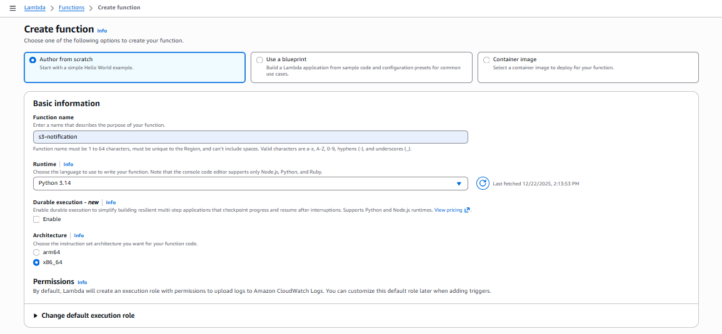
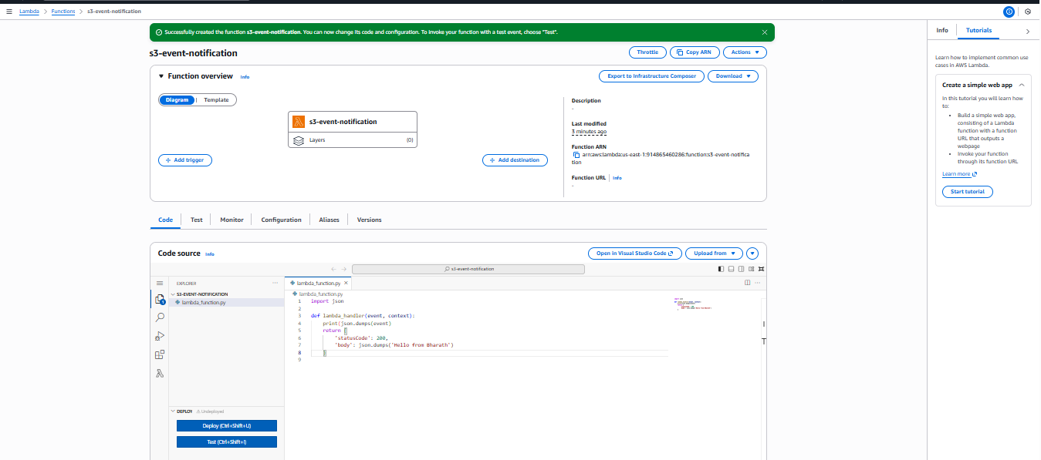
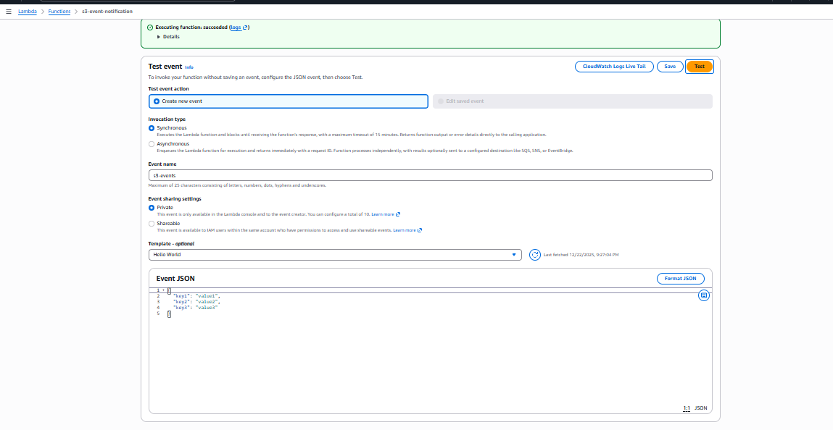

Test Lambda Function
- Created a test event
- Invoked the function manually
- Verified:
  - Status code: 200
  - Response: "Hello from Lambda!"
  - Logs available in CloudWatch

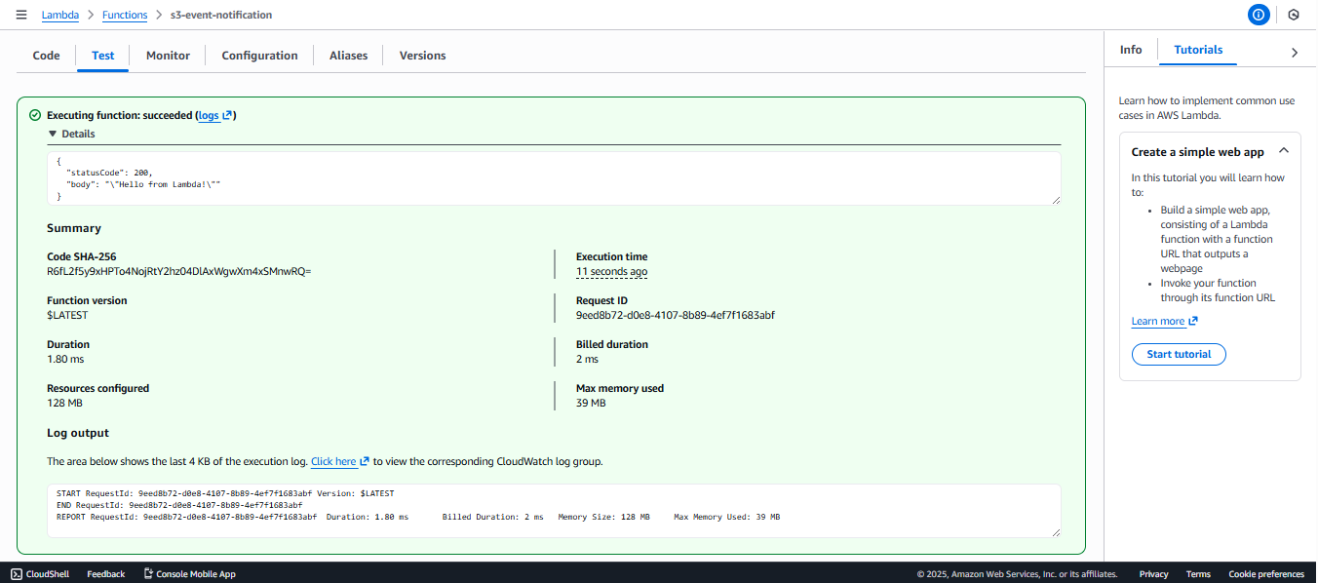

Create S3 Bucket
- Bucket name: s3-event-lambda-useast-1
- Region: us-east-1
- Bucket type: General purpose
- Object ownership: ACLs enabled

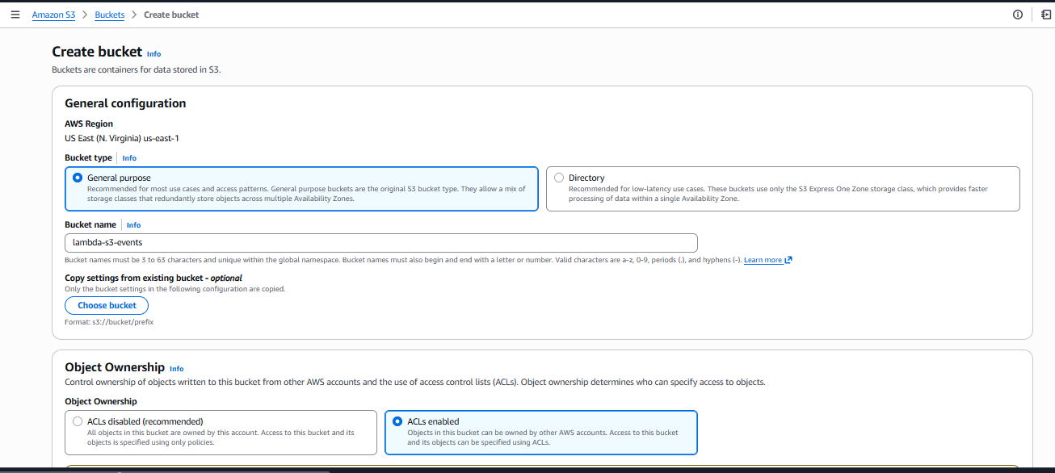

Create SNS Topic
- Topic name: simple-notification
- Protocol: Email
- Endpoint: Email address
- Subscription status: Confirmed (via email confirmation link)
✅ SNS topic is ready to send email notifications.

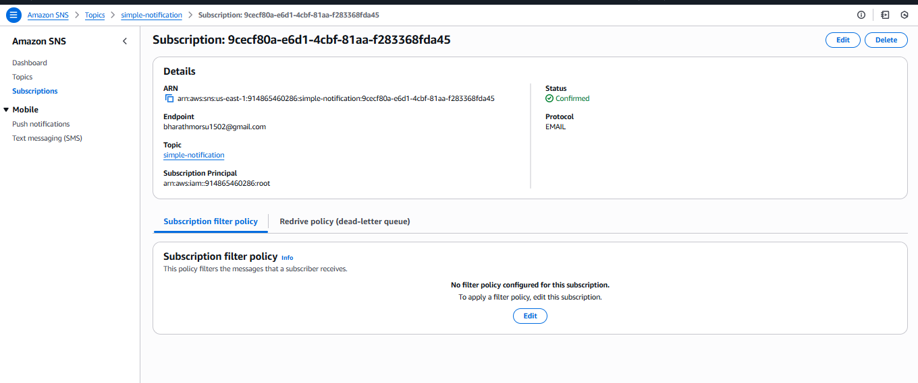
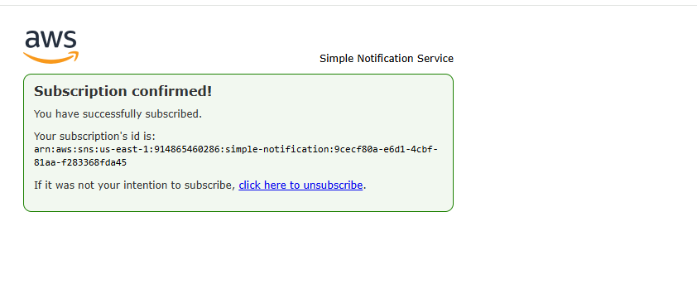

Configure S3 Event Notification
- Bucket: s3-event-lambda-useast-1
- Event name: s3-notification-event
- Event type: ObjectCreated (Put)
- Optional filters:
  - Prefix: images/
  - Suffix: .jpg
- Destination: AWS Lambda function

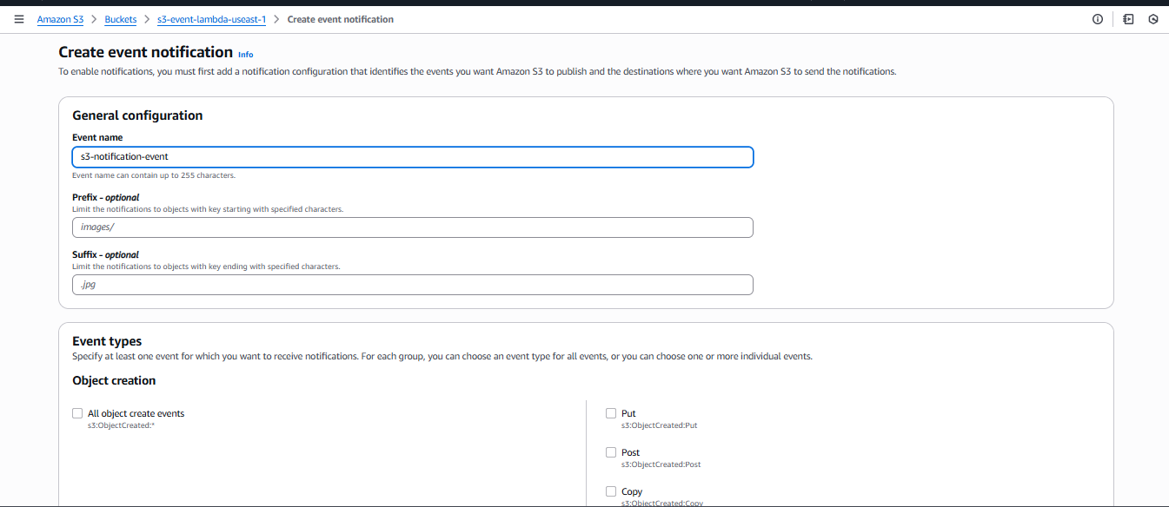
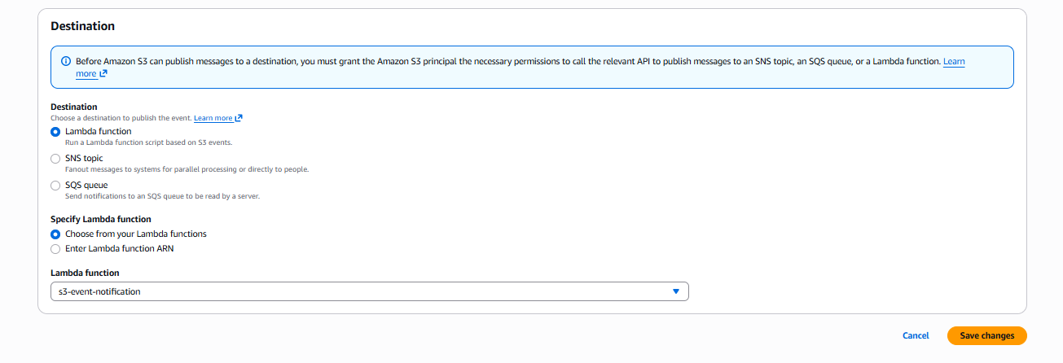
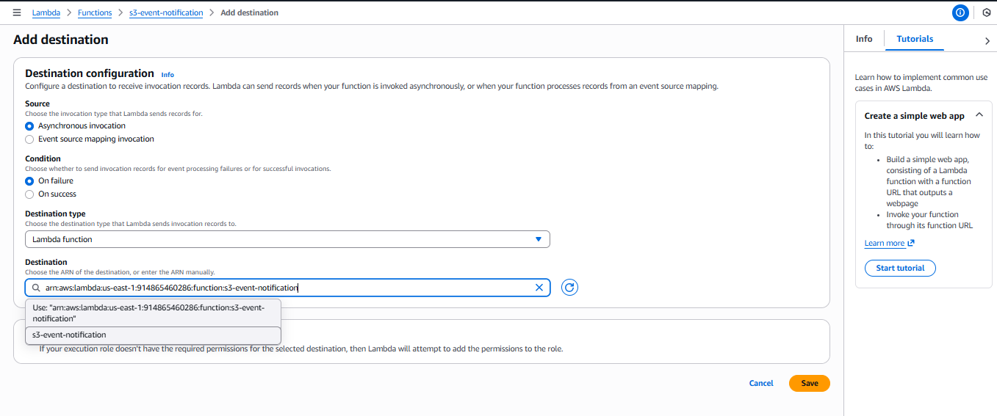

Upload Object to S3
- Uploaded file: sample.txt
- Triggered:
  - S3 ObjectCreated event
  - Lambda execution
  - SNS email notification

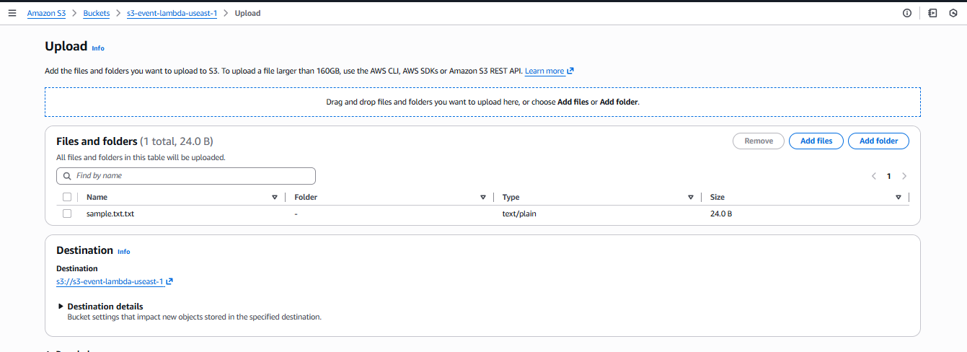
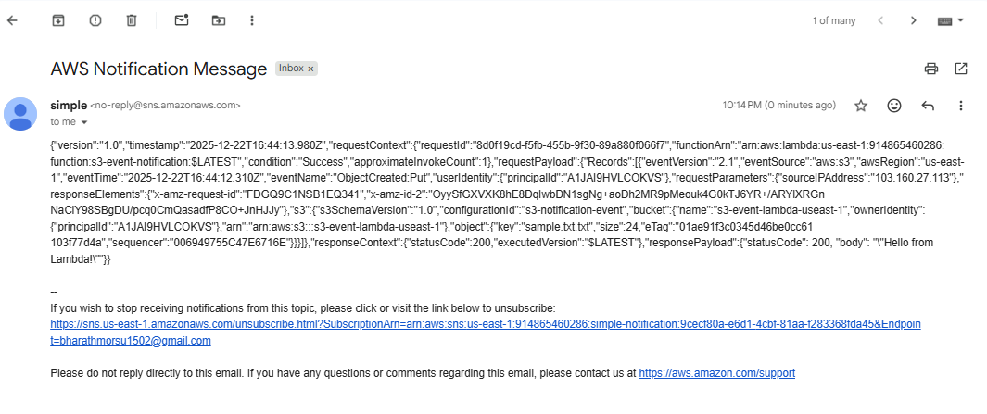

Validation Steps
✔ Lambda execution succeeded
✔ CloudWatch logs generated
✔ SNS topic published message
✔ Email notification received
✔ Event details included:
- Bucket name
- Object key
- Event time
- Request ID
- Lambda response

Output (Email Notification)
- Received an email from AWS SNS
- Included:
  - S3 event metadata
  - Lambda execution status
  - Request and response details

Issues Faced
- SNS email subscription requires manual confirmation
- Lambda permissions must allow invocation from S3
- Region mismatch between services can cause trigger failure

Conclusion
Successfully implemented an event-driven serverless notification system using AWS services.
This setup ensures real-time notifications whenever files are uploaded to an S3 bucket, without managing servers, making it scalable, cost-effective, and production-ready.

API Gateway – Lambda Integration

Task Title
Create AWS Lambda Function and Integrate with API Gateway

Objective

To create an AWS Lambda function using Python, test it successfully, and expose it through Amazon API Gateway so it can be invoked via an HTTP endpoint.

Prerequisites
- AWS account with permissions for Lambda and API Gateway
- Basic understanding of AWS Lambda and API Gateway
- Internet browser access to AWS Management Console

Create a Lambda Function
- Navigate to AWS Console → Lambda → Functions → Create function
- Select Author from scratch
- Enter Function name: API-gateway
- Select Runtime: Python 3.14
- Choose Architecture: x86_64
- Leave default execution role settings
- Click Create function

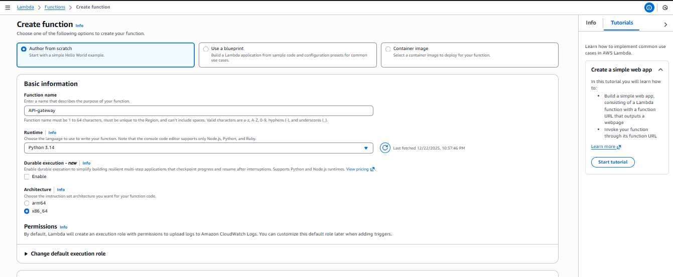
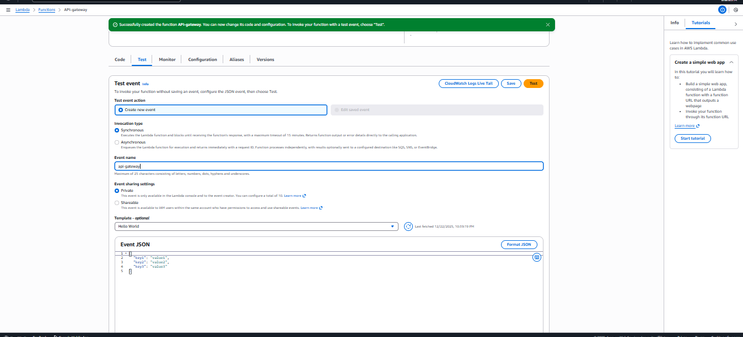

Test the Lambda Function
- Open the Test tab in the Lambda console
- Click Create new event
- Enter Event name: api-gateway
- Use default JSON template
- Click Save, then Test
- Confirm the response returns:
{
"statusCode": 200,
"body": "Hello from Lambda!"
}

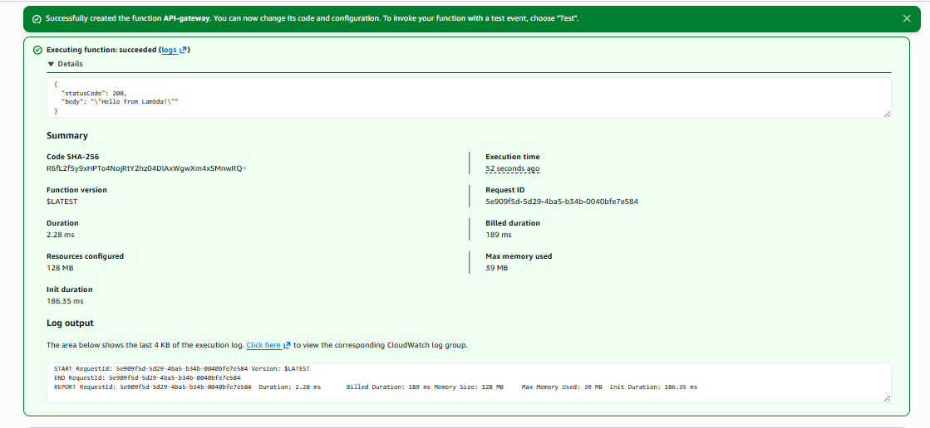

Add API Gateway Trigger
- Go to Lambda → Configuration → Triggers → Add trigger
- Select API Gateway
- Choose Create a new API
- Select API type: REST API
- Set Security: Open
- Click Add

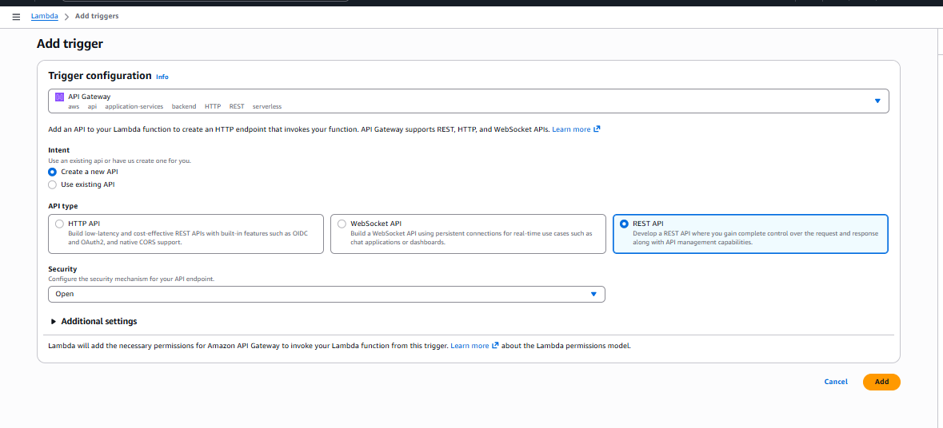
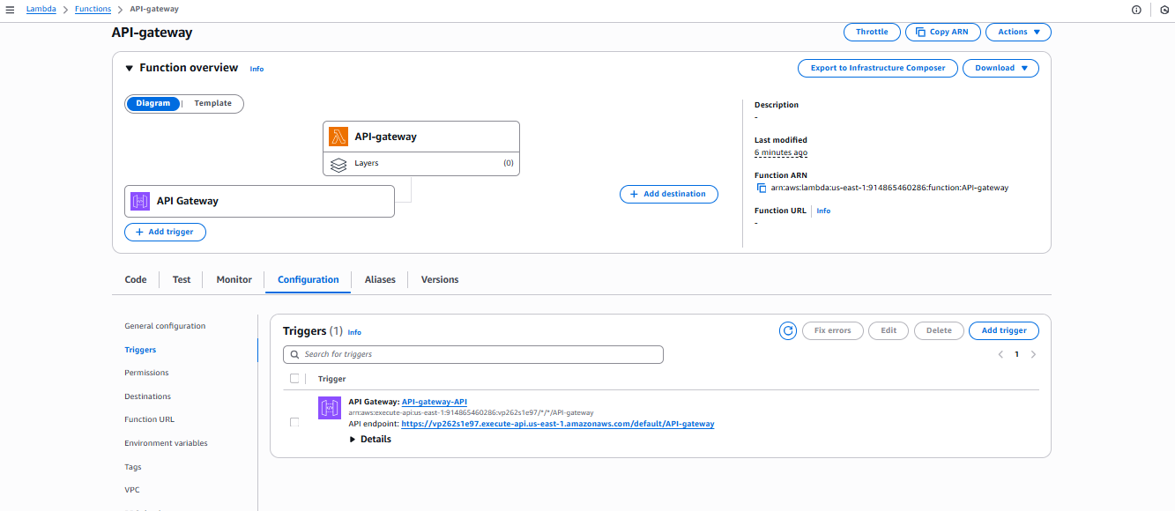

Deploy and Access API Endpoint
- After trigger creation, note the API endpoint URL
- Open the URL in a browser
- Verify the output displays:
Hello from Lambda!
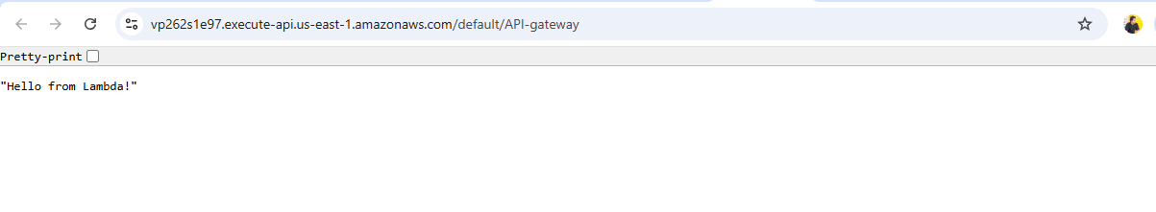

Validation Steps
- Lambda test event executes successfully with status code 200
- CloudWatch logs show successful execution
- API Gateway endpoint returns expected response in browser
- No permission or integration errors observed

Issues Faced
- Initial confusion between HTTP API and REST API selection
- Required understanding that "Open" security allows public access

Conclusion
The AWS Lambda function was successfully created and integrated with Amazon API Gateway. The function responds correctly when invoked directly and through the API Gateway endpoint, confirming successful serverless application deployment.

